BREAKING NEWS: CHILLVENTA PREMIERE
Virtus 5
Eckelmann will be presenting its new system center Virtus 5 at Chillventa for the first time and introducing the new product line "Virtus LINE". This equips refrigeration systems for the digital future of refrigeration technology.
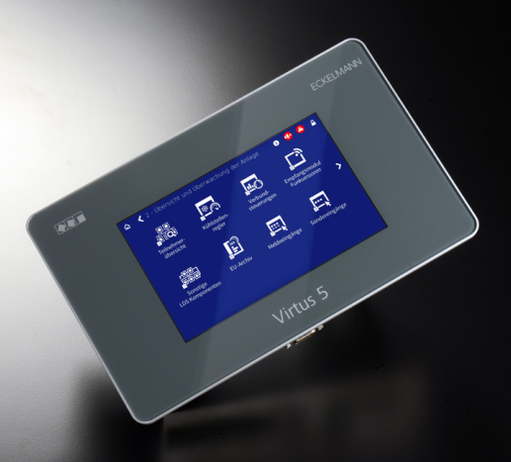

Caption: Virtus 5, Eckelmann's new system center for the digitally networked refrigeration plant of the future (Photo: Eckelmann AG)

Wiesbaden (Germany), October 16, 2018: With the new Virtus LINE product line, Eckelmann meets the demands of a world that is increasingly digitally networked. At Chillventa 2018 the company is presenting the Virtus 5 as the first product of the Virtus LINE – the exact product name being VSC 5x00 for "Virtus System Center". It will be available for purchase starting in February 2019 in a basic and extended version. The new system control center for the E*LDS control system replaces the CI 4x00 product family. E*LDS is one of the leading control systems for industrial and commercial refrigeration in Europe.
With the powerful hardware platform, Eckelmann opens up many possibilities of digitization for refrigeration companies and operators of refrigeration systems. Of course, this includes the secure encrypted connection to cloud systems as well as the integration of refrigeration unit and compound controllers from the new product line – together with the next generation of smart field components from Eckelmann.
Modern web and IoT technologies allow the use of cloud applications to intelligently optimize plants during operation, such as through Condition Monitoring or Predictive Maintenance with AI-based methods. Externally, the Virtus 5 convinces by an altogether narrower design with a noble anthracite-colored display frame and the lower weight.
For configuration, a touch display is available and a modern web interface, which can be used in any browser independent of platform, so that no additional configuration software is needed. Visitors at the booth of Eckelmann can learn about the new web-based operating concept, which meets the increased demands of today's users regarding an intuitive interaction design.

Strong innovation partner for refrigeration technology 4.0
"The generation, provision and evaluation of data streams from machines, plants and buildings creates unimagined possibilities for providing digital services," explains Dr. Ing. Frank Uhlemann: "We no longer only think in sectors or markets. We think in 'digital ecosystems' and we are establishing new partnerships. This is why we would also like to enter into dialogue with users, operators and other manufacturers at Chillventa. Whatever will be possible in refrigeration tomorrow, we are designing together today! Anyone who thinks linearly is overtaken exponentially. With the Virtus 5 from Eckelmann and the new Virtus LINE, our customers in 27 countries around the world are ready for the challenges of digitization."

Upgrade for existing plants
The Virtus 5 is downward compatible with older E*LDS components. Existing plants can therefore easily move to the more powerful Virtus 5 platform. This gives operators investment security and, at the same time, they can benefit from the rapid technological developments of the coming years – from digitization to Industry 4.0 & IoT to the use of artificial intelligence.
In addition, Eckelmann offers a pure software upgrade (CI 5x00) for the system center of the CI 4x00 family. This also provides a cost-optimized way for older systems to benefit from the new web-based operating concept and to connect to modern cloud or IoT applications. For example, refrigeration contractors and operators of existing systems can gradually switch to the new, standardized E*LDS operating concept, although the extended functionality and excellent performance of the new Virtus 5 cannot be achieved on the old hardware platform.

More information on new products by Eckelmann at the Chillventa 2018:
www.eckelmann.de/en/products-solutions/refrigeration/chillventa/

Chillventa 2018
October 2018, 16-18, Nuremberg
Hall 5, booth 5-110

About Eckelmann AG
Eckelmann AG, Wiesbaden, is a medium-sized automation partner for machine, equipment and plant construction. Its focus is on the development and series production of optimized control solutions for machines as well as programming and system integration for control and automation systems. Important target sectors are: mechanical engineering, plant engineering for metal and plastics processing, chemicals and pharmaceuticals, commercial refrigeration, food, basic and building materials, mills and food industry, medical technology. Eckelmann AG was founded in 1977 by Dr.-Ing. Gerd Eckelmann.

www.eckelmann.de

Kontakt:  Eckelmann AG  Berliner Straße 161  65205 Wiesbaden  Germany  Phone: +49 (0)611 7103-0  info@eckelmann.de  www.eckelmann.de | Media Relations:  Pressebüro Schwitzgebel  Felix Berthold  Berliner Straße 2  55283 Nierstein  Germany  Phone: +49 (0)6133 50954-1  Mobile: +49 (0)162 4367696  f.berthold@presse-schwitzgebel.de  www.presse-schwitzgebel.de

