On the pulse of digitalization

Wiesbaden (Germany), September 28, 2018: Automation and digitalization in refrigeration today and tomorrow: Where are we heading? At the Chillventa 2018 (Hall 5, Booth 110), Eckelmann AG will be showing trend-setting and benefit-oriented solutions with E*LDS. Visitors can look forward to many product innovations. Eckelmann will kick off the first day of the trade fair by announcing an exclusive Chillventa product premiere, which future technologies are already using to make inroads into refrigeration technology.
Customers in 27 countries worldwide now rely on E*LDS from Eckelmann as one of the leading control systems for refrigeration systems in industrial and commercial refrigeration. "For more than 20 years, we have been successfully developing electronics and software solutions specifically for refrigeration and building automation," explains Dr. Frank Uhlemann. "With innovative solutions and new technologies, we are continuously opening up new applications for our customers – for safe, efficient and climate-friendly refrigeration technology. At this year's Chillventa, we would therefore like to provide targeted stimulus for further digitization of refrigeration technology and share exclusive insights into our latest innovations."

1,211 characters (without headline)

More information: www.eckelmann.de/en/products-solutions/refrigeration/chillventa/

Chillventa 2018
October 16-18, 2018, Nuremberg
Hall 5, Booth 5-110

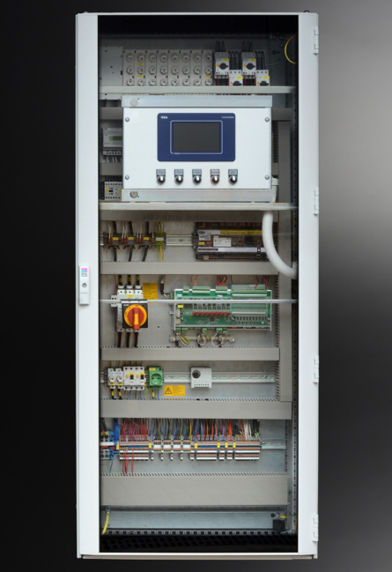

Image caption 1: At Chillventa 2018, Eckelmann will be giving exclusive insights into the future of refrigeration and building automation. (Photo: Eckelmann AG)

About Eckelmann AG
Eckelmann AG, Wiesbaden, is a medium-sized automation partner for machine and system engineering as well as cooling technology. The focus is on the development and series production of optimized control solutions for machines as well as programming and system integration for automation systems. Important target industries are: mechanical engineering, plant construction for metal and plastics processing, chemicals and pharmaceuticals, industrial and commercial refrigeration, raw materials and building materials, mills and food industry, medical technology. Eckelmann AG was founded 1977 by Dr.-Ing. Gerd Eckelmann.

www.eckelmann.de/en/

Contact:  Eckelmann AG  Berliner Straße 161  65205 Wiesbaden  Germany  Tel.: +49 (0)611 7103-0  info@eckelmann.de  www.eckelmann.de | Media Relations:  Pressebüro Schwitzgebel  Felix Berthold  Berliner Straße 2  55283 Nierstein  Germany  Tel.: +49 (0)6133 50954-1  Mobil: +49 (0)162 4367696  f.berthold@presse-schwitzgebel.de  www.presse-schwitzgebel.de

