Digitize part shapes on the machine bed

Wiesbaden, September 18, 2018: Eckelmann presents at the EuroBLECH 2018 among other things an innovative image processing solution for the digitization of part shapes – with high precision and in full size. It is an optional extension for the Eckelmann CNC cutting application that is fully integrated into the user interface of the machine. A ruggedized camera on the machining head scans the contour of the template. The scan data are automatically vectorized and can easily be imported as DXF files into the CAD/CAM nesting software or used as G code for NC programs on the machine. Of course, the digitized templates can be archived in the operator terminal.
The scanner is conveniently calibrated using a DataMatrix code. "In the future, the system will also support a height calibration to compensate for a possible machine bed tilt," says machine vision expert Arno Dewald: "This is especially interesting when large-area contour templates are to be scanned with high accuracy."
Typical application examples for this function of the E°SEE package are the digitization of part shapes to provide spare parts, e.g. for broken excavator buckets or the digitization of existing technical drawings and templates. By seamlessly integrating the vision system into the CNC automation system, the solution fits perfectly into workflow-integrated job planning on the machine.
The scanner solution for gantry cutting machines can be experienced live in action at the Eckelmann booth, E°SIM Cut, the virtual 3D-simulator for cutting machines makes it possible.

EuroBLECH
October 23-26, 2018, Hanover
Hall 11, Booth E08
Exhibitor profile
VIDEO: https://youtu.be/4Df2vPxuVd0

Further Information:
Machine Automation
Machine Vision
Machine Simulation
CNC Cutting Solutions

Press photos and captions, see p. 2.

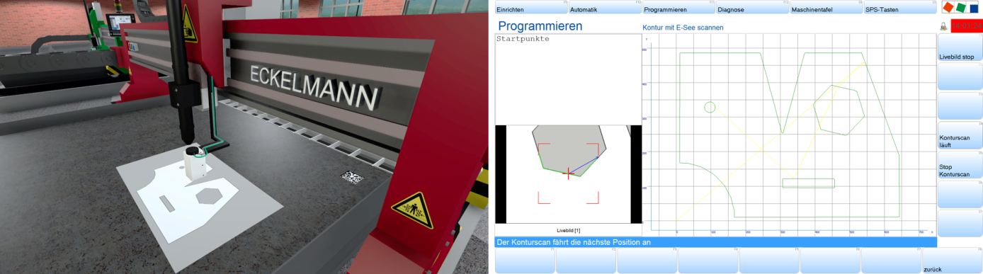

Caption: E°SEE digitizes part shapes directly on the machine bed and is optimally integrated into the CNC user interface. (Photo: Eckelmann AG)

About Eckelmann AG
Eckelmann AG, Wiesbaden, is a medium-sized automation partner for machine, equipment and plant construction. Its focus is on the development and series production of optimized control solutions for machines as well as programming and system integration for control and automation systems. Important target sectors are: mechanical engineering, plant engineering for metal and plastics processing, chemicals and pharmaceuticals, commercial refrigeration, food, basic and building materials, mills and food industry, medical technology. Eckelmann AG was founded in 1977 by Dr.-Ing. Gerd Eckelmann. Around 420 employees of the Eckelmann Group generated an output of 70 million Euros in the financial year of 2017.

www.eckelmann.de

Contact:  Eckelmann AG  Berliner Straße 161  65205 Wiesbaden  Phone: +49 (0)611 7103-0  info@eckelmann.de  www.eckelmann.de | Media Relations:  Pressebüro Schwitzgebel  Dr. Frieder Schwitzgebel  Berliner Straße 2  55283 Nierstein  Phone: +49 (0)6133 50954-1  Mobil: +49 (0)172 6190178  f.schwitzgebel@presse-schwitzgebel.de  www.presse-schwitzgebel.de

