Eckelmann @ The Big 5
Smart automation for the Middle East

Eckelmann continues to expand its activities in the Middle East growth market. At the Big 5 in Dubai in November, the company will present solutions for mechanical and plant engineering, building automation and infrastructure.

Wiesbaden (Germany), November 19, 2019: Eckelmann AG will be presenting itself at Big 5 in Dubai from 25 to 28 November as a broad-based solution partner for automation and digitization. For 4 days, the global players of the construction industry will meet in the Persian Gulf, around 67,000 trade visitors from 140 countries are expected.
"We are currently experiencing a unique construction boom and growing demand for automation solutions in the United Arab Emirates and the Gulf states," explains Hassan Mousa, Sales Manager Middle East at Eckelmann AG and responsible for machine automation. "Automation and digitization 'Made in Germany' is very popular in the Emirates. For Eckelmann, this important growth market offers many opportunities. We would like to use the Big 5 to expand our contacts in the region and intensify existing business relationships with machine and plant manufacturers as well as operators".
The globally active solution provider, headquartered near Frankfurt on the Main, sees many points of contact. These include solutions from Eckelmann for the energy-efficient control of refrigeration systems and building automation. Another focal point is the growing need for automation on the part of local machine manufacturers, as the United Arab Emirates has long ceased to meet its demand for machines solely through imports. Innovative machine manufacturers in Dubai such as Accumech already rely on complete CNC solutions from Eckelmann to make their laser cutting machines locally and internationally competitive; other important fields of application include metal and sheet metal processing, the window industry and the furniture industry.
Eckelmann has been at home in all automation disciplines since 1977 and has many years of expertise as a system integrator on the basis of standard components. Eckelmann implements sophisticated 4.0 solutions for production, material flow and logistics, with numerous relevant references ranging from steelworks, the food and beverage industry and chemicals & pharmaceuticals to the building materials industry and tank control systems for fuel supply at major airports.
2,103 characters incl. blanks (without headline and teaser)
The Big 5
25.11.-28.11.2019, Dubai World Trade Center
Hall 6, Booth Z6 F30

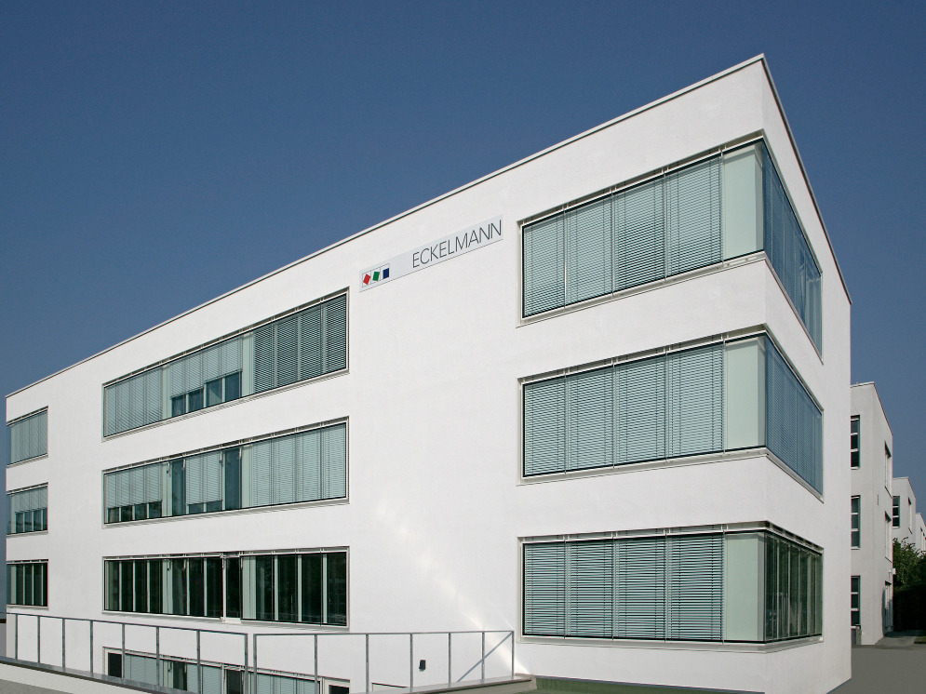
Caption: Eckelmann AG in Wiesbaden (Photo: Eckelmann AG)

About Eckelmann AG
Eckelmann AG, Wiesbaden, is a medium-sized automation partner for machine, equipment and plant construction. Its focus is on the development and series production of optimized control solutions for machines as well as programming and system integration for control and automation systems. Important target industries are: Mechanical engineering, plant construction for metal and plastics processing, chemicals and pharmaceuticals, industrial refrigeration, food, basic and building materials, mills and the food industry, medical technology. Eckelmann AG was founded in 1977 by Dr.-Ing. Gerd Eckelmann. Around 480 employees of the Eckelmann Group generated an output volume of 74 million euros in the 2018 financial year.
www.eckelmann.de

Contact:  Eckelmann AG  Berliner Street 161  65205 Wiesbaden  Tel.: +49 (0)611 7103-0  info@eckelmann.de  www.eckelmann.de | Media Relations:  Press office Schwitzgebel  Dr. Frieder Schwitzgebel  Berliner Street 2  55283 Nierstein  Mobil: +49 (0)172 6190178  f.schwitzgebel@presse-schwitzgebel.de  www.presse-schwitzgebel.de

