Eckelmann expands activities in Italy
BTE Automazione is a new partner of Eckelmann AG in Italy and exclusively sells solutions for machine automation.

Wiesbaden, Nov 13, 2019: BTE Automazione and Eckelmann AG signed a strategic sales partnership in October. The Italian family-owned company headquartered in Bellusco, near Milan, has extensive expertise as a system integrator in the field of laser, plasma and water jet CNC cutting.
Together with BTE Automazione, Eckelmann is laying the groundwork for further growth in one of the world's core mechanical engineering markets. Looking at world production of machine tools, Italy ranks fourth with a market share of 8.3 percent, and is growing solidly with brisk domestic demand. Executive Marco Münchhof emphasizes: "We are thus also responding to multiple requests from Italian mechanical engineers. Like many internationally established machine manufacturers, they also want to use our reliable CNC solution packages, e.g. for cutting machines. The proven flexibility and easy customization of our solutions ensures you decisive competitive advantages. Not only medium-sized companies appreciate the high quality and reliability of our customized one-stop solutions for complete automation technology and the software for its application."
BTE Automazione will advise local Italian mechanical engineers and assist them with the implementation of Eckelmann's CNC solutions. "We have been in close contact with the management for one and a half years," says Münchhof: "We are pleased that we can now seal this successful cooperation by creating an official Italian Eckelmann agency."
Today, to help manufacturers of industrial automation solutions with systems that reduce development time, you need products that are easy to apply, guarantee long spare parts availability, and deliver high levels of durability. In addition, BTE Automazione, as a local partner, offers a service that immediately provides competent answers. "In the Italian market in particular, flexibility and dynamism are key success factors," says Alessandro Besana, Managing Director of BTE Automazione. "Added to that is the need to be rooted logistically and culturally in the region." With many years of customer service experience in the industrial sector, BTE Automazione combines the highest level of professional service and support, leveraging the latest generation of products as a solution partner. "Eckelmann products have been synonymous with innovation and reliability for many years. And Eckelmann is always open and attentive to new requirements and customer requests," emphasizes Besana. "The combination of the experience of the two parties now creates an ambitious project. Our stated goal is to advise and assist manufacturers of automation systems in Italy in the best possible way, together with Eckelmann as a solution provider with comprehensive industry know-how."
2,734 characters incl. blanks (without headline and teaser)

LinkedIn page of of BTE Automazione: https://www.linkedin.com/company/bte-automazione/

Eckelmann Machine Automation:
https://www.eckelmann.de/en/products-solutions/machine-automation/

SPS ‒ Smart Production Solutions
11/26 to 11/28 2019, Nuremberg
Hall 7, Stand 314

www.eckelmann.de/sps19

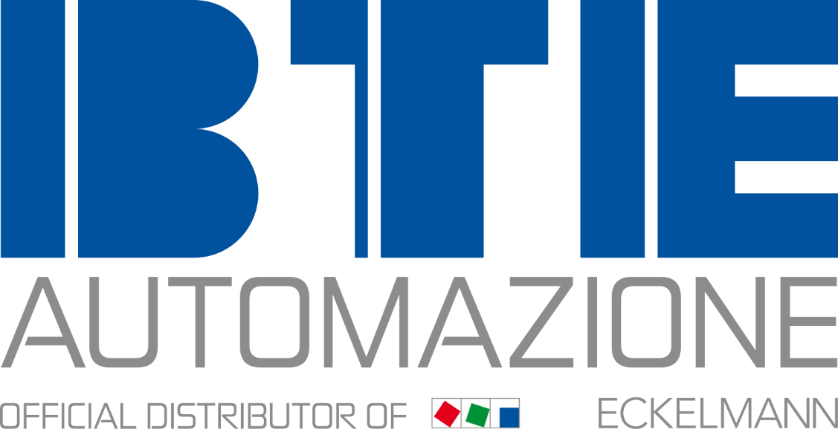

Caption: BTE Automazione is the official Italian distribution partner of Eckelmann. (Photo: BTE Automazione)

About Eckelmann AG
Eckelmann AG, Wiesbaden, is a medium-sized automation partner for machine, equipment and plant engineering. Their focus is on the development and serial production of optimized control solutions for machines as well as programming and system integration for control and automation systems. Important target industries are: mechanical engineering, plant engineering for metal and plastics processing, chemicals and pharmaceuticals, commercial refrigeration, food, raw materials and building materials, mills and food industry, and medical technology. Eckelmann AG was founded in 1977 by Dr.-Ing. Gerd Eckelmann. Around 480 employees of the Eckelmann Group generated revenues of €74 million in fiscal year 2018.
www.eckelmann.de

Contact:  Eckelmann AG  Berliner Straße 161  65205 Wiesbaden  Tel.: +49 (0)611 7103-0  info@eckelmann.de  www.eckelmann.de | Media Relations:  Schwitzgebel Press Office  Dr. Frieder Schwitzgebel  Berliner Straße 2  55283 Nierstein  Cell: +49 (0)172 6190178  f.schwitzgebel@presse-schwitzgebel.de  www.presse-schwitzgebel.de

