Eckelmann expands its presence in France
Wiesbaden, 30.10.2019: Eckelmann has increased its local presence in France by opening a new distribution office near Paris. Baudelaire Meli Dountsop has been appointed for the newly introduced position of Sales Manager France. He took up his position in April 2019.
"We want to make our products and technologies more popular in the French-speaking region and thus further expand the E*LDS market share into one of the largest European markets," says Thomas Behr, Head of Sales, explaining the strategic decision. "Our customers in France will benefit from a closer relationship with the manufacturer. Innovative solutions in refrigeration and building automation require intensive communication with customers. The specific technical requirements, wishes, and expectations of our customers have top priority when it comes to the ongoing development of our control system for supermarket refrigeration and future digital solutions. Monsieur Meli Dountsop has the necessary expertise and excellent knowledge of the French market".
Meli Dountsop has been working with refrigeration and air conditioning since his school days in Cameroon, and after graduating from a technical high school, he studied heat engineering and energy in France. With a specialization in refrigeration technology, he holds two master's degrees, a master's in industrial engineering and a master's in quality, safety, and environment. Meli Dountsop has gained professional experience at companies in the field of energy and air-conditioning technology, including a renowned French manufacturer of air-conditioning systems and chillers. He speaks French, English and some German.
1,629 characters (without headline)

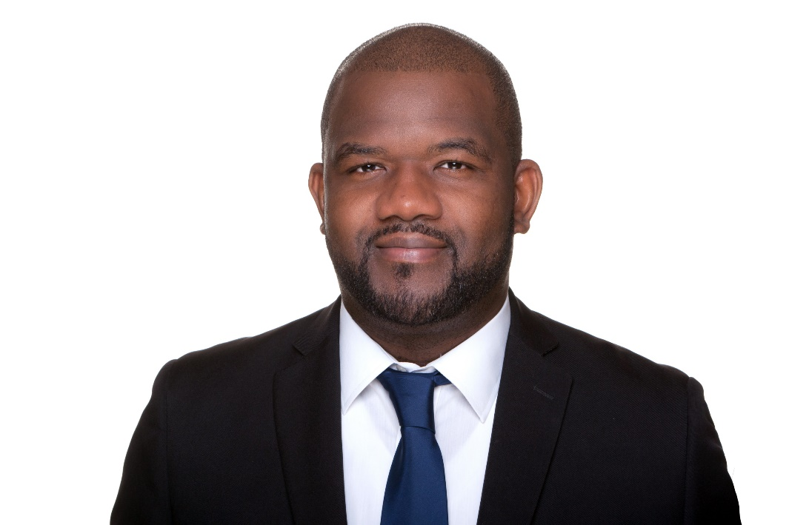

Picture caption: Baudelaire Meli Dountsop (Photo: Eckelmann AG)

About Eckelmann AG
Eckelmann AG, Wiesbaden, is a medium-sized provider of automation solutions for machines, industrial plants, and devices. Our primary focus is the development and serial production of optimized control solutions for machines as well as programming and integrating automation and control systems. Major target industries are Mechanical engineering, plant construction for metal and plastics processing, chemicals and pharmaceuticals, industrial refrigeration, foodstuffs, basic materials and building materials, mills and foods industry, medical technology. Eckelmann AG was founded in 1977 by Dr. Ing. Gerd Eckelmann.

www.eckelmann.de

Contact:  Eckelmann AG  Berliner Straße 161  65205 Wiesbaden  Germany  Phone: +49 (0)611 7103-0  info@eckelmann.de  www.eckelmann.de | Media relations:  Schwitzgebel Press Office  Felix Berthold  Berliner Straße 2  55283 Nierstein  Germany  Phone: +49 (0)6133 50954-1  Cellphone: +49 (0)162 4367696  f.berthold@presse-schwitzgebel.de  www.presse-schwitzgebel.de

