A single-cable solution: Connect compressors digitally

Wiesbaden (Germany), 6 August 2019: The VS 3010 compressor and condenser controller from Eckelmann now supports the Modbus connection of BITZER’s ECOLINE compressors. This new functionality can now be obtained as a purchasable firmware update. It reduces the cabling effort to a minimum and speeds up the implementation of the intelligent compressors. The compressor is connected to the control cabinet via just a single Modbus cable. Even existing systems can easily be switched to BITZER’s newest generation of compressors, thereby protecting past investments in measurement, control and regulation technology.
Thanks to the digital Modbus communication, the compressor no longer needs to be manually set up in the compressor controller, since all the configuration data relating to the compressor is stored within the BITZER IQ module. The module takes over the monitoring, controlling and diagnosing of the compressor in full and thereby ensures efficient and safe operation. Prewired sensors and actuators on the IQ module also eliminate the need for individual cabling in the compressor controller. The new Modbus single-cable solution therefore reduces the overall complexity and the potential for errors when putting modern compressors into operation!
In conjunction with the CRII capacity controller from BITZER, a quasi-continuous capacity adjustment of 10 to 100% can be achieved.
1,356 characters (excluding heading)

Further information regarding the VS 3010 (operating instructions, data sheet, application examples):
https://edp.eckelmann.de/edp/lds/_Cm5qxI6op3:EN

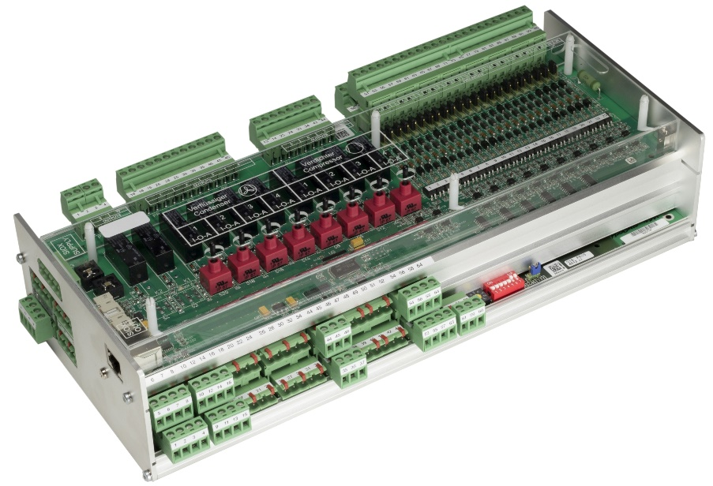

Image 1: The VS 3010 compressor and condenser controller from Eckelmann is now compatible with BITZER Ecoline compressors using the IQ module. (Photo: Eckelmann AG)

About Eckelmann AG
Eckelmann AG, Wiesbaden, is a medium-sized provider of automation solutions for machines, industrial plants, and devices. Our primary focus is the development and serial production of optimized control solutions for machines as well as programming and integrating automation and control systems. Major target industries are Mechanical engineering, plant construction for metal and plastics processing, chemicals and pharmaceuticals, industrial refrigeration, foodstuffs, basic materials and building materials, mills and foods industry, medical technology. Eckelmann AG was founded in 1977 by Dr. Ing. Gerd Eckelmann.

www.eckelmann.de

Contact:  Eckelmann AG  Berliner Straße 161  65205 Wiesbaden  Germany  Phone.: +49 (0)611 7103-0  info@eckelmann.de  www.eckelmann.de | Media relations:  Schwitzgebel Press Office  Felix Berthold  Berliner Straße 2  55283 Nierstein  Germany  Phone.: +49 (0)6133 50954-1  Cellphone: +49 (0)162 4367696  f.berthold@presse-schwitzgebel.de  www.presse-schwitzgebel.de

