New Maxi and Mini Alarm Boxes
With the new E*LDS Alarm Boxes Maxi and Mini from Eckelmann, operators and refrigeration companies are playing it safe!

Wiesbaden (Germany), September 25, 2019: The new E*LDS Maxi Alarm Box (W x H x D: 110 x 180 x 90 mm) by Eckelmann is the ideal solution for CO₂ gas warning devices, temperature alarms and more. The combined optical/acoustic signal device ensures greater safety and can be used extremely flexibly. The compact alarm box is optionally equipped with a digital temperature display (BT30).
Alarm signals are activated via a potential-free contact, e.g. gas warning devices for CO₂ systems in cold rooms, temperature monitors, emergency call devices in deep-freeze rooms or similar monitoring tasks. The alarm signal can also be connected to other alarm devices by means of an additional potential-free changeover contact.
To deactivate the alarm signal, which has a pulsating tone of 90-95 dB, the reset button on the front panel needs to be pressed. The optical signal (flashing light) will continue after the reset button has been pressed for as long as the alarm remains active or until the cause has been eliminated.
The Eckelmann portfolio now also includes the new E*LDS Mini Alarm Box (W x H x D: 110 x 110 x 90 mm) specifically for CO₂ gas detectors. It features a flashing light with horn in 24V DC version. The horn, flashing light and reset button are wired to the terminal, so the alarm box can be connected to practically any gas warning control system with a 24V DC digital output.
1,349 Characters (without headline and teaser)

Data Sheets E*LDS Alarm Boxes:
https://edp.eckelmann.de/edp/lds/_zszwR96Z1T:EN

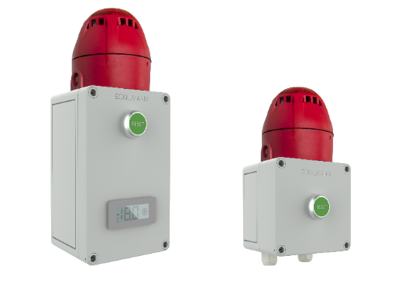

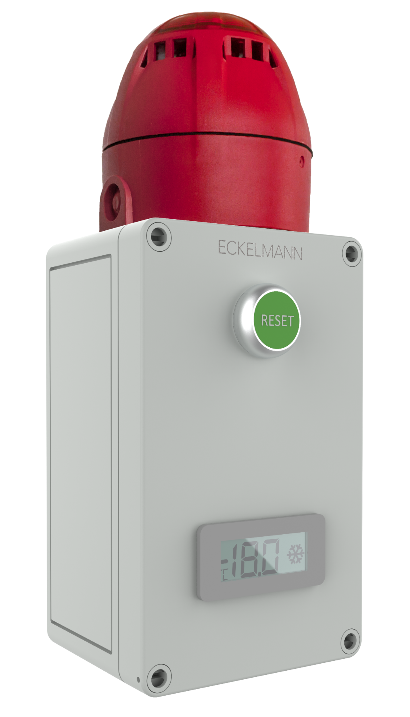

Caption: E*LDS Alarm Box Maxi and Mini for CO₂ gas warning devices, temperature alarms and more (Photo: Eckelmann AG)

About Eckelmann AG
Eckelmann AG, Wiesbaden, is a medium-sized provider of automation solutions for machines, industrial plants, and devices. Our primary focus is the development and serial production of optimized control solutions for machines as well as programming and integrating automation and control systems. Major target industries are Mechanical engineering, plant construction for metal and plastics processing, chemicals and pharmaceuticals, industrial refrigeration, foodstuffs, basic materials and building materials, mills and foods industry, medical technology. Eckelmann AG was founded in 1977 by Dr. Ing. Gerd Eckelmann.

http://www.eckelmann.de/en

Contact:  Eckelmann AG  Berliner Straße 161  65205 Wiesbaden  Germany  Phone.: +49 (0)611 7103-0  info@eckelmann.de  www.eckelmann.de | Media relations:  Schwitzgebel Press Office  Felix Berthold  Berliner Straße 2  55283 Nierstein  Germany  Phone.: +49 (0)6133 50954-1  Cellphone: +49 (0)162 4367696  f.berthold@presse-schwitzgebel.de  www.presse-schwitzgebel.de

