RefStep Oy is Eckelmann's new commercial agency for Finland
Kellokoski (Finland)/Wiesbaden, 6/27/2019: The Finnish company RefStep Oy and Eckelmann AG signed a cooperation agreement in May 2019. RefStep is the exclusive distributor for E*LDS solutions in Finland and advises customers who use the control system for refrigeration equipment and building automation that is used throughout Europe in the food retail sector.
“In recent 20 years, I have come to know and appreciate E*LDS as an especially flexible and efficient control system,” emphasized Jani Kääriäinen, managing director of RefStep and electrical engineer. “That's why I'm thrilled that we have the opportunity to raise awareness of Eckelmann's innovative solutions here in Finland as an official partner. Both operators of refrigeration systems and cooling specialists in Finland benefit from our many years of experience in planning, implementing, optimizing, and remotely monitoring systems with E*LDS.”
With its presence in Finland, Eckelmann is continuing the internationalization of its distribution. “In partnering with RefStep, we have gained a renowned expert for our refrigeration electronics and digital solutions,” said sales manager Thomas Behr. “Innovative solutions thrive on customer dialog, which Jani Kääriäinen and his team are now also engaging in for Eckelmann in Finnish and with a high level of expertise. In addition to expanding our market share in northern Europe, we'd also like to offer the best service to our customers for our products and services. That's why we require our distributors to be specialists and to be able to support our customers with any questions in a solution-oriented way, from planning to quick spare part support.”
1,630 characters (without headline)

Further information:
- RefStep Oy's website: www.refstep.fi/
- E*LDS: https://www.eckelmann.de/en/products-solutions/refrigeration/
- Technical documentation: edp.eckelmann.de/edp/lds/start

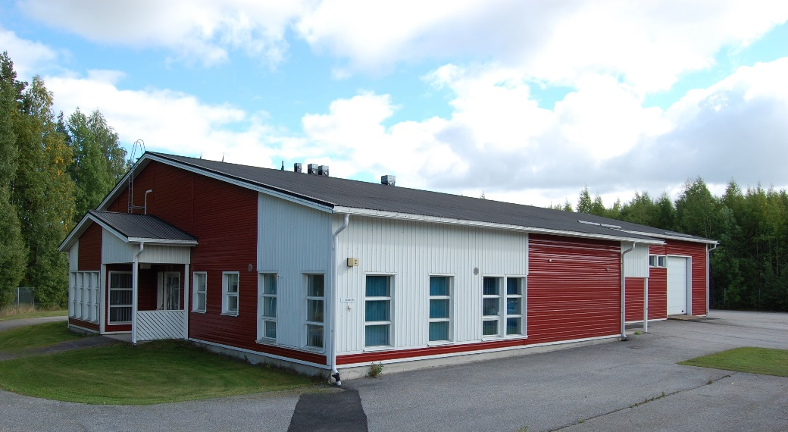

Image caption 1: RefStep's registered office in Kellokoski, approx. 50 km north of Helsinki (photo: RefStep Oy)

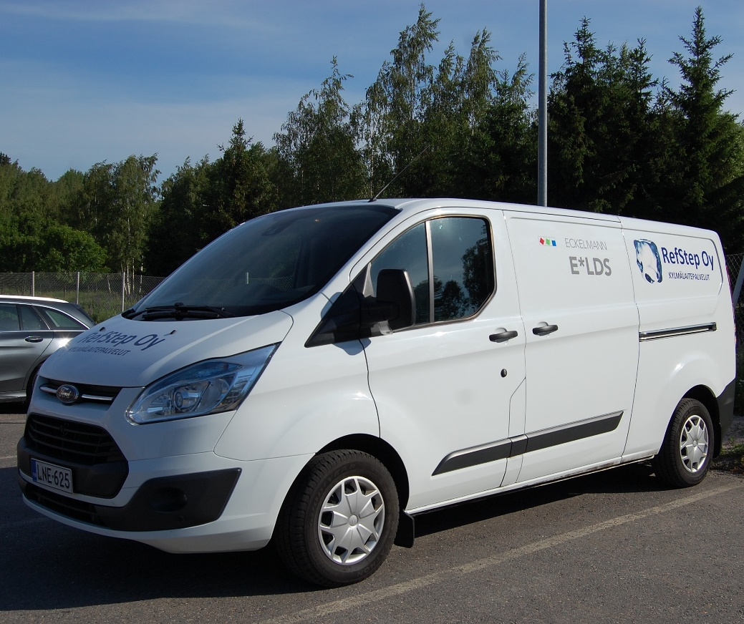

Image caption 2: Closer to the customer: RefStep Oy and Eckelmann AG are cooperating in Finland (photo: RefStep Oy)

Image caption 3: Jani Kääriäinen (photo: RefStep Oy)

About Eckelmann AG
Eckelmann AG, based in Wiesbaden, is a medium-sized automation partner for mechanical engineering, equipment construction, and plant engineering. Its main focuses include the development and series production of optimized control solutions for machines as well as programming and system integration for control and automation systems. Some important target industries are: Mechanical engineering, plant engineering for metal working and plastic processing, chemistry and pharmaceuticals, commercial refrigeration, foodstuffs, raw materials and building materials, mills and the food industry, and medical technology. Eckelmann AG was founded by the engineer Gerd Eckelmann in 1977.

www.eckelmann.de

Contact:  Eckelmann AG  Berliner Straße 161  65205 Wiesbaden  Tel.: +49 (0)611 7103-0  info@eckelmann.de  www.eckelmann.de  RefStep Oy  Sällintie 2  04500 Kellokoski  Finland  Tel.: 040 588 0879  Email: info@refstep.fi | Media relations:  Pressebüro Schwitzgebel  Felix Berthold  Berliner Straße 2  55283 Nierstein  Tel.: +49 (0)6133 50954-1  Mobile phone: +49 (0)162 4367696  f.berthold@presse-schwitzgebel.de  www.presse-schwitzgebel.de

