The laser experience makes the difference!
Together with its partner Accumech, Dubai, the Eckelmann AG will present innovative automation solutions at the Steelfab, Sharjah (UAE) from 13 to 16 January 2020, hall 6, booth 4200.

Wiesbaden (Germany), January 8th, 2020: Eckelmann will present its automation solutions for CNC laser cutting machines at the Steelfab 2020, Sharjah (UAE). The medium sized company with its headquarter near Frankfurt, Germany is a co-exhibitor of its machine engineering partner Accumech from Dubai.
„Our controllers have been used successfully in laser cutting and marking applications for more than 20 years and are continuously developed further, in terms of functionality, performance and usability”, explains Hassan Mousa, Eckelmann’s Regional Sales Manager Middle East. He points out: “Machine manufacturers and integrators benefit from fast engineering and an open ear for innovative functionalities.”
The machine, which Accumech will show at the Steelfab, is the result of a close innovation cooperation. “I’m happy that the full-range of our portfolio as a One-Stop-Solution-Provider is utilized in this exceptional machine,” says Mousa. From touch-optimized HMI and controllers for CNC/SPS/Motion with integrated safety functionalities up to the drive systems, all system components and the software of Eckelmann are perfectly coordinated. They can be used both as a standard system as well as a customized solution to meet any individual need in machine automation.
Mousa emphasizes: “With high-performance and sustainable automation concepts, we want to create a competitive edge for our customers all around the globe. And with our new OPC-UA based ‘Machine Management System’ we also provide an open solution to foster digital connectivity in medium sized manufacturing companies. Our digital solutions are vendor-independent, and the integration of other controllers and machines is possible with minimal effort.”
1.687 characters (including blanks), without headline and teaser

Learn more about Eckelmann CNC cutting solutions:
https://www.eckelmann.de/en/products-solutions/machine-automation/cutting/

Further information about the Machine Management System:
https://www.eckelmann.de/mms

Video of the machine on the YouTube Channel of Eckelmann AG:
https://youtu.be/ssa6fP8n95w

Further information about our partner Accumech, Dubai:
https://www.cncaccumech.com/

STEELFAB
13.01-16.01.2020, Sharjah - UAE
hall 6, booth 4200
https://steelfabme.com/
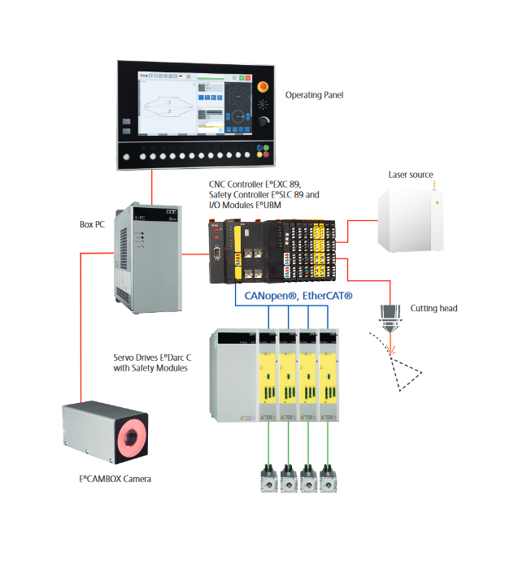

Caption 1: Complete automation for laser cutting machines. (Graphic: Eckelmann)

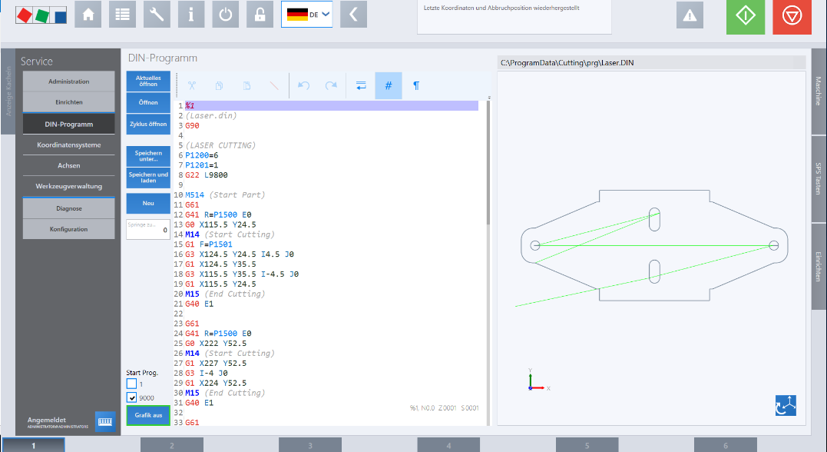

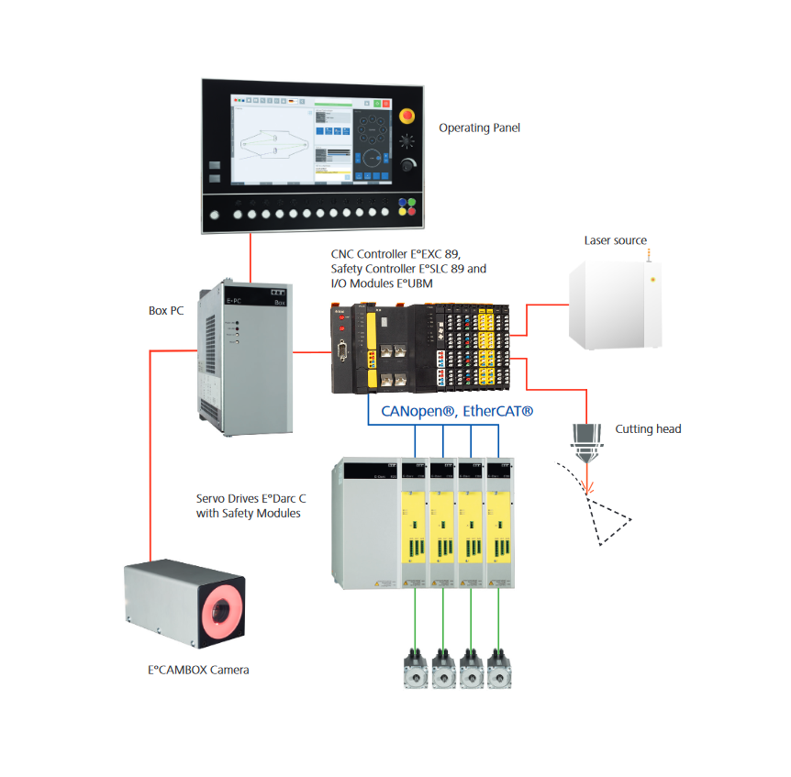

Caption 2: Eckelmann HMI package for laser cutting machines (Photo: Eckelmann AG)

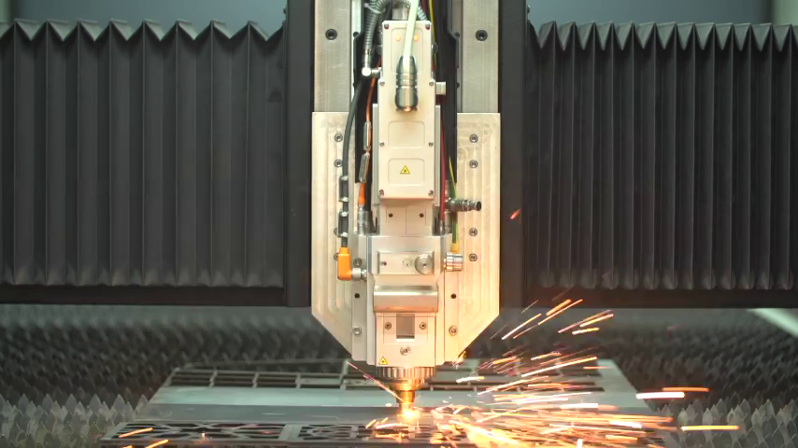
Caption 3: Laser cutting head in action (Photo: Accumech)

About Eckelmann AG
Eckelmann AG, Wiesbaden, is a medium-sized automation partner for machine, equipment and plant construction. Its focus is on the development and series production of optimized control solutions for machines as well as programming and system integration for control and automation systems. Important target industries are: Mechanical engineering, plant construction for metal and plastics processing, chemicals and pharmaceuticals, industrial refrigeration, food, basic and building materials, mills and the food industry, medical technology. Eckelmann AG was founded in 1977 by Dr.-Ing. Gerd Eckelmann. Around 480 employees of the Eckelmann Group generated an output volume of 74 million euros in the 2018 financial year.
www.eckelmann.de

Contact:  Eckelmann AG  Berliner Street 161  65205 Wiesbaden  Germany  Phone: +49 (0)611 7103-0  info@eckelmann.de  www.eckelmann.de | Media Relations:  Press office Schwitzgebel  Dr. Frieder Schwitzgebel  Berliner Street 2  55283 Nierstein  Germany  Phone: +49 6133 509541  Mobile: +49 (0)172 6190178  f.schwitzgebel@presse-schwitzgebel.de  www.presse-schwitzgebel.de

