Press Release by Eckelmann AG

AWJ Energy from Saudi Arabia and Eckelmann cooperate

Wiesbaden (Germany), XX.09.2021: AWJ Energy from Saudi Arabia and Eckelmann AG from Germany start a new cooperation. Both companies have signed an exclusive cooperation agreement in September 2021. The common goal is the sustainable transition of the energy sector in the Kingdom of Saudi Arabia through building automation and digitalization solutions.
“We are proud to announce the new partnership with AWJ Energy. As a medium-sized company, we pursue the goal to expand our activities in growing target markets with technically experienced local cooperation partners”, emphasizes Thomas Behr, Vice President Refrigeration & Building Automation at Eckelmann AG. “Together, we want to accelerate the sustainable digital transition of the energy sector by advanced building automation and digitalization technologies. Especially our system solutions for energy efficient and safe control of refrigeration systems and building automation are very popular in Europe for many years because of their high adaptability and scalability. We see great growth potential for our technologies in the Kingdom of Saudi Arabia and look forward to a successful cooperation."
“This new relationship with Eckelmann brings in carries an immense value to us as one of the recognized business houses in Saudi Arabia”, says Hassan B Al Qahtani, CEO at AWJ ENERGY. “AWJ Energy is a flagship company of ATAR Holding. It acts as an enabler, facilitator, and supplier for the region’s energy ecosystems. It identifies and plugs gaps in capability and capacity by developing bespoke supply chains that rely on carefully vetted international expertise. With World-class partnerships and tie-ups, we bring in the best products, sustainable solutions, and services to KSA clients. This partnership is yet another example of our commitment to Vision 2030 and brings in the World-class products and technologies for Growth sectors.”

1.866 characters (including blanks)

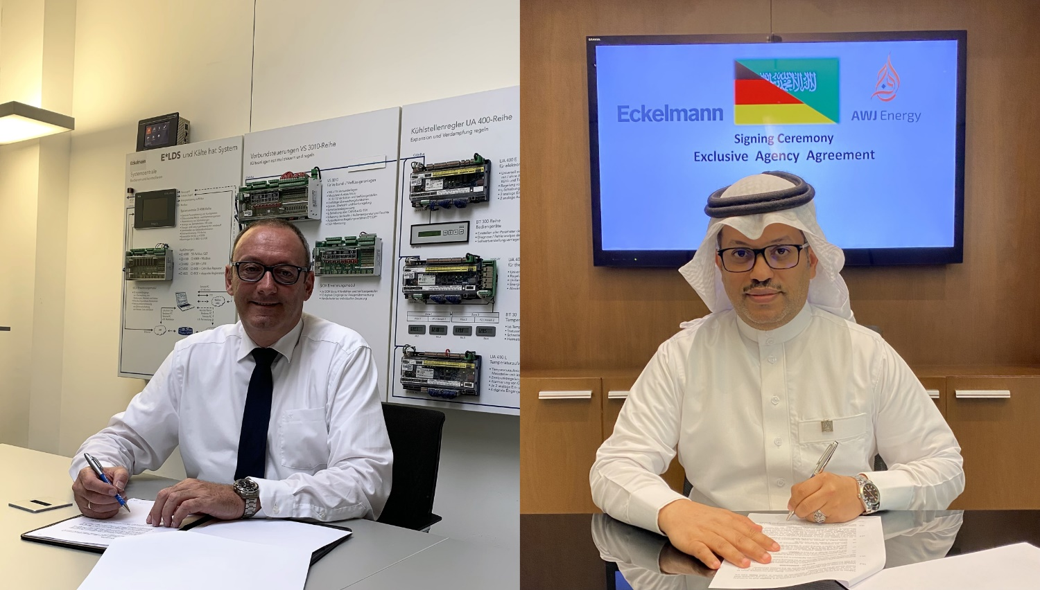
Caption: Thomas Behr, Vice President Refrigeration & Building Automation at Eckelmann AG and Hassan B Al Qahtani, CEO at AWJ ENERGY sign an exclusive cooperation agreement. (Foto: Eckelmann / AWJ ENERGY)

About Eckelmann AG
Eckelmann AG, Wiesbaden, is a medium-sized automation partner for machinery, apparatus, and plant engineering. Its main focuses are the development and serial production of optimised control solutions for machinery and programming and system integration for control and automation systems. Important target industries are: Machine engineering, plant manufacturing for metal and plastics processing, chemistry and pharmaceuticals, commercial refrigeration, foodstuffs, basic and construction materials, mills and the food industry, medical technology. Eckelmann AG was founded in 1977 by Dr.-Ing. Gerd Eckelmann.

Contact:  Eckelmann AG  Berliner Straße 161  65205 Wiesbaden  Germany  Tel.: +49 (0)611 7103-0  info@eckelmann.de  www.eckelmann.de | Media Relations:  Pressebüro Schwitzgebel  Felix Berthold  Im Krämereck 9  55276 Oppenheim  Germany  Phone: +49 (0)162 4367696  Phone: +49 (0)172 6190178 (Pressebüro, Oppenheim)  f.berthold@presse-schwitzgebel.de  www.presse-schwitzgebel.de

