A new website for Eckelmann
After a comprehensive relaunch, the new Eckelmann AG website went online at the turn of the year at: www.eckelmann.de.

Wiesbaden, January 18th, 2021: Eckelmann AG has comprehensively revised its website: www.eckelmann.de. New content and new design sharpen the company's profile and provide a quick overview of the solution partner's portfolio for automation and digitization. User-friendly structures and navigation optimized for mobile devices allow visitors to find their way around quickly.
"Who are we? What are we doing and why? What unique benefits does Eckelmann generally create for its customers? We are now answering these questions concisely on the consciously minimalist homepage and with a clear positioning statement, ”explains Johannes Stelter. The electrical engineer with a doctorate is responsible for business development at the Eckelmann Group. Stelter emphasizes: "On the upper levels of the new website we make our values and culture of customer orientation tangible."
Visitors can find detailed information on products, solutions and services on the subpages. Eckelmann is now devoting a separate area to the general topic of digitization.
The newly designed word mark, which is being presented for the first time with the new website, underlines the claim to transparency and clarity with its powerful design. It exudes the pride of the Eckelmann Group, which with its more than 500 employees has been promoting customers in various industries with excellent solutions for 44 years.
The career area has also been completely restructured so that applicants can find out more about current vacancies and the Eckelmann Group as an employer.

www.eckelmann.de

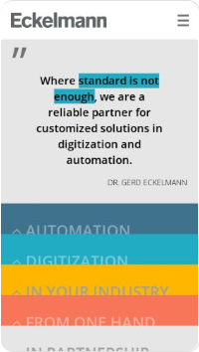
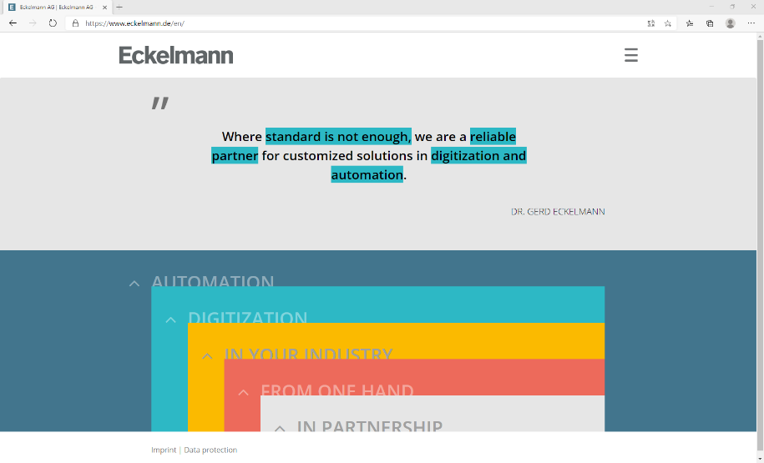

Caption 1: Eckelmann's new website (Photo: Eckelmann AG)

Caption 2: Dr.-Ing. Johannes Stelter (Photo: Eckelmann AG)

About Eckelmann AG
Eckelmann AG, Wiesbaden, is a medium-sized automation partner for machine, device and plant construction. Its focus is on the development and series production of optimized control solutions for machines as well as programming and system integration for control and automation systems. Important target industries are: mechanical engineering, plant construction for metal and plastics processing, chemicals and pharmaceuticals, commercial refrigeration, food, basic and building materials, mills and the food industry, medical technology. Eckelmann AG was founded in 1977 by Dr.-Ing. Gerd Eckelmann. Around 525 employees of the Eckelmann Group generated an output of 73 million euros in the 2019 financial year.

www.eckelmann.de

Contact:  Eckelmann AG  Berliner Straße 161  65205 Wiesbaden  Tel.: +49 (0)611 7103-0  info@eckelmann.de  www.eckelmann.de | Media Relations:  Pressebüro Schwitzgebel  Dr. Frieder Schwitzgebel  Berliner Straße 2  55283 Nierstein  Mobil: +49 (0)172 6190178  f.schwitzgebel@presse-schwitzgebel.de  www.presse-schwitzgebel.de

