Press Release by Eckelmann AG

MicroStep Europa and Eckelmann Cooperate

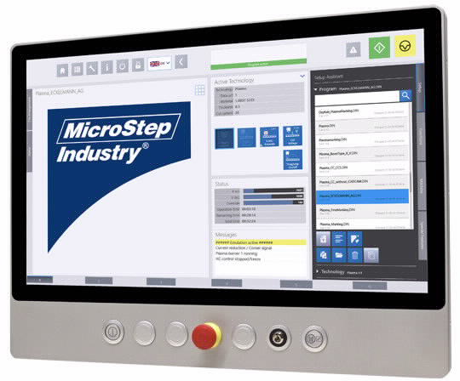

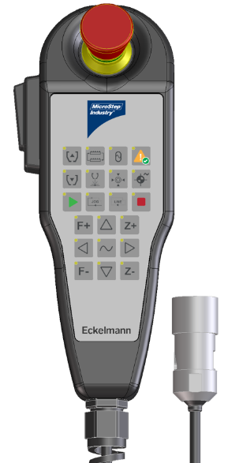

Figure 1: MSE SmartControl is the first joint development by MicroStep Europa and Eckelmann. It allows the latest generation MSE SmartFL fiber laser machines to be operated intuitively via a robust 21.5 inch industrial panel PC running Eckelmann's already IIoT-capable E°Cut HMI. In addition, flexible operation is made possible by a handheld control unit, which has been optimally adapted to the application in terms of functionality and design. (Photo: Eckelmann AG / MicroStep Europa GmbH)

Wiesbaden (Germany), 20.07.2021: MicroStep Europa GmbH presents its new fiber laser cutting machine as a first result of the technology and innovation cooperation with Eckelmann AG, Wiesbaden. The cooperation started in January 2021. Together, the two companies want to introduce revolutionary Industry 4.0 concepts for sheet metal processing of the future and to this end are both involved in the medium-sized company oriented Industry Business Network 4.0 e.V. (IBN 4.0).
The new MSE SmartFL series is Industry 4.0-ready for use with the multi-vendor, European IIoT networking solution IndustryFusion. The open-source networking solution for smart factories and smart products is an IBN 4.0 initiative and allows interoperable linking of machines, factories, and cloud platforms. IndustryFusion is designed to enable companies of all sizes to digitize their manufacturing process and gain access to a broad Industry 4.0 ecosystem that thrives on the plurality and diversity of medium-sized players in the market. To support digitization, it is of course also possible to use the machine series with FactoryWare MMS: The manufacturer- and technology-independent Machine Management System from Eckelmann offers medium-sized sheet metal working companies in particular a lightweight entry into the digitization and networking of machines.
Johannes Ried, Managing Director of MicroStep Europa: "Among other things, the development of its own CNC control technology has made MicroStep a partner in demand worldwide when it comes to meeting highly complex requirements in the fields of cutting and automation. Accordingly, our expectations of a supplier regarding the control technology for MicroStep Europa GmbH's new standard MSE SmartFL laser series were demanding. Today we know: With Eckelmann, we have gained more than just a new development partner and supplier for automation technology. In particular, we were convinced by a profound common understanding of what control technology and operating concepts should look like that are optimally geared to networking heterogeneous machine parks and advanced digital workflows."
2,094 characters (including blanks)
Further Information:
- New laser series: entry into high-quality 2D cutting (Press release by MicroStep Europa)
- More information about MSE SmartControl, a joint development of MicroStep Europa and Eckelmann
- Eckelmann CNC Cutting Solutions
- Industry Business Network 4.0
- IndustryFusion, the European IIoT Networking Solution
- FactoryWare MMS

About Eckelmann AG
Eckelmann AG, Wiesbaden, is a medium-sized automation partner for machine, device and plant construction. Its focus is on the development and series production of optimized control solutions for machines as well as programming and system integration for control and automation systems. Important target industries are: mechanical engineering, plant construction for metal and plastics processing, chemicals and pharmaceuticals, commercial refrigeration, food, basic and building materials, mills and the food industry, medical technology. Eckelmann AG was founded in 1977 by Dr.-Ing. Gerd Eckelmann. Around 525 employees of the Eckelmann Group generated an output of 73 million euros in the 2019 financial year.

Kontakt:  Eckelmann AG  Berliner Straße 161  65205 Wiesbaden  Germany  Tel.: +49 (0)611 7103-0  info@eckelmann.de  www.eckelmann.de | Media Relations:  Pressebüro Schwitzgebel  Im Krämereck 9  55276 Oppenheim  Germany  Tel.: +49 (0)172 6190178  info@presse-schwitzgebel.de  www.presse-schwitzgebel.de

