Press Release by Eckelmann AG
FactoryWare MMS 2021.1 Standard Edition is Available
Eckelmann launches its Machine Management System for the digitalization of sheet metal processing in medium-sized companies. This is how Industry 4.0 works with CAD/CAM and CNC cutting know-how par excellence.
Higher quality, efficiency, and productivity in manufacturing – made possible by the innovative Machine Management System of Eckelmann. FactoryWare MMS offers a lightweight cloud solution for the step-by-step digitalization of sheet metal processing and turns an existing machine park into a medium-sized "smart factory" with minimum effort. As of 1 June 2021, FactoryWare MMS 2021.1 Standard Edition is available: https://www.factoryware.de/en/mms-en/ .

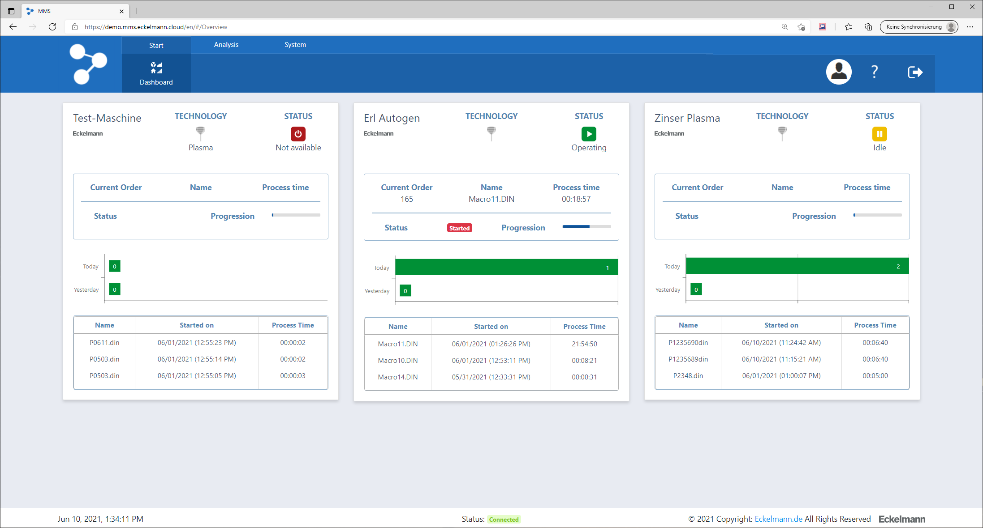
Figure 1: FactoryWare MMS offers machine manufacturers and operators an easy entry into digitalization. The screenshot shows the machine dashboard of the web-based cloud application. (Photo: Eckelmann AG)
Wiesbaden, 15.06.2021: FactoryWare MMS (www.factoryware.de/en/mms-en/) by Eckelmann is a manufacturer- and technology-independent Industry 4.0 solution for sheet metal processing in medium-sized companies. With the innovative web-based Machine Management System (MMS), manufacturing companies can digitalize and securely network existing and new machines with minimum integration effort.
Machines with current E°EXC controllers and E°CUT HMI from Eckelmann can be integrated easily via software adapters. For existing machines or machines from other manufacturers, Eckelmann and partners can provide suitable machine adapters or retrofit solutions. The open plug-in interface is an important prerequisite for existing machines and brownfield factories to benefit from subsequent digitalization – at comparatively low investment costs. Thanks to the use of vendor-independent IIoT protocols such as MQTT and OPC-UA, FactoryWare MMS offers maximum flexibility and openness in this regard.

Starting June 1, 2021, FactoryWare MMS will be available with the functionality provided by the Standard Edition and can be used with a fair and transparent pay-per-use pricing model:

- Machine dashboard with visualization of the connected machines
- Clear reporting on machine status and errors
- Machine status with graphical display of machine utilization and drill-down analysis of machine states
- Integration and display of sensor data via MQTT
- System management and administration
- User administration
- Available languages: English and German user interface and online help
- Measurement system: metric

Premiere Use Case
The company C.E. Schneckenflügel GmbH (https://schneckenfluegel.de/en/) is a pilot customer of FactoryWare MMS. It was possible to improve their cutting time by 10 percent per shift in a very short time thanks to the operating data that are automatically collected, displayed and processed for Schneckenflügel.

"FactoryWare MMS has a lot of potential because it creates a very solid data basis for networked manufacturing and knows how to integrate interfaces to job planning or CAD/CAM systems in a holistic and manufacturer-independent way. This is how digitalization really gets us ahead in the mid-sized sector", says Managing Director Rolf Eiting with conviction and continues: "After the initial digital networking of our large Zinser plasma cutting system, we want to integrate 8 press brakes without Eckelmann controller in the next step. This step-by-step approach makes digitalization very manageable for us in our machine park that has grown over time. We can decide ourselves what and how much we want to digitalize. As a cloud application, FactoryWare MMS is very flexible and can be scaled according to use, just like a pay-per-use service. This is certainly still a new approach in our industry, but it also makes the costs and benefits of digitalization directly transparent for us."
"We have designed FactoryWare MMS with 'openness' in mind, so we can integrate the system across a heterogeneous machine environment via open interfaces. This also includes existing systems such as CAD/CAM systems, ERP or automated warehouse management", explains Jaron Sprute, Senior Software Developer at Eckelmann. Together with his team of Lisa Sieburger, Dominik Arendt and Arne Müller, he developed the MMS. "The continuous further development and roll-out of new functions will make our Industry 4.0 cloud application a real enabler for digital transformation in medium-sized manufacturing companies. Software editions with extended functionality or options, e.g. for CAD/CAM and cutting, are already in preparation and are expected to be available in 2021."

You can only improve what you measure

"True to the motto 'If you only knew what you know’, FactoryWare MMS automatically aggregates existing data in manufacturing and brings it together centrally”, explains Boris Spangenberg, Product Manager for CAD/CAM, Digitalization and Cutting at Eckelmann. In this way, plant data collection supports users in identifying optimization potential and bottlenecks. Reporting, including an individual Report Designer and real-time reporting functions on the machine status, makes it possible to continuously measure and evaluate parameters. "You can only improve what you measure”, emphasizes Boris Spangenberg.

"FactoryWare MMS is a highly adaptable software system for the efficient implementation of digital workflows on the shop-floor and can be used both stationary and mobile with so-called companion apps. Practical concepts for the secure connection of machines ensure low barriers to entry, regardless of whether the machine is already IIoT-capable or first has to be digitalized and networked via suitable software adapters”, explains Boris Spangenberg. "FactoryWare MMS offers largely scalable control system and management functions at the interface between ERP and the machine world, making it particularly attractive for medium-sized manufacturing companies that want to intelligently tap into and evaluate their previously unused production data in order to improve their processes and workflows continuously and develop new services. The possibilities are vast and range from regular reporting to optimize machine utilization to new concepts for predictive consumables management, for example for torch heads. In any case, our customers can already look forward to more great features in FactoryWare MMS."

6.250 characters (including blanks)

Further information about FactroyWare MMS – including video:

https://www.factoryware.de/en/mms-en/

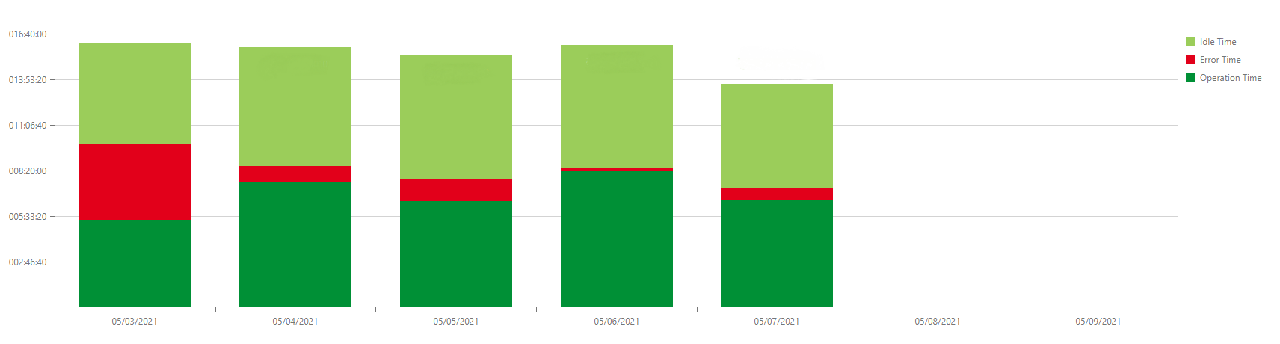

Figure 2: Reporting: Machine status (offline, idle, operating, error) (Photo: Eckelmann AG)

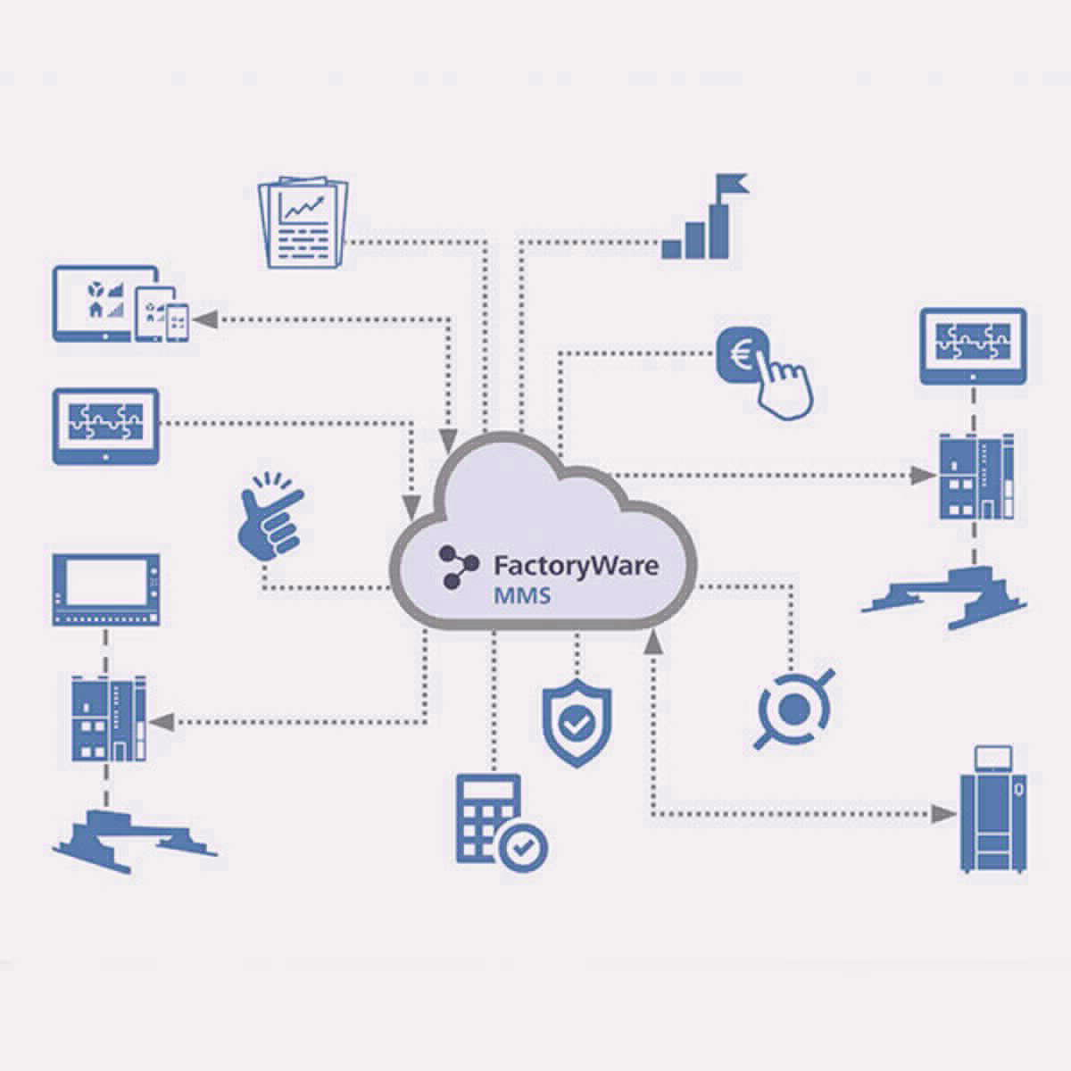

Figure 3: FactoryWare MMS from Eckelmann is an open ecosystem for the step-by-step digitalization and networking of any machine and creates consistent interfaces for more interoperability between all participants and services of the automation pyramid – from the controller and field level to the CAD/CAM & ERP system. Every company can use FactoryWare securely and independently in its own cloud instance – for maximum data security. The communication of the integrated machines with the MMS is secured hardware-based End-to-End Encryption. (Graphic: Eckelmann AG)

About Eckelmann AG
Eckelmann AG, Wiesbaden, is a medium-sized automation partner for machine, device and plant construction. Its focus is on the development and series production of optimized control solutions for machines as well as programming and system integration for control and automation systems. Important target industries are: mechanical engineering, plant construction for metal and plastics processing, chemicals and pharmaceuticals, commercial refrigeration, food, basic and building materials, mills and the food industry, medical technology. Eckelmann AG was founded in 1977 by Dr.-Ing. Gerd Eckelmann. Around 525 employees of the Eckelmann Group generated an output of 73 million euros in the 2019 financial year.

Kontakt:  Eckelmann AG  Berliner Straße 161  65205 Wiesbaden  Germany  Tel.: +49 (0)611 7103-0  info@eckelmann.de  www.eckelmann.de | Media Relations:  Pressebüro Schwitzgebel  Im Krämereck 9  55276 Oppenheim  Germany  Tel.: +49 (0)172 6190178  info@presse-schwitzgebel.de  www.presse-schwitzgebel.de

