Press Release by Eckelmann AG
SPS – Smart Production Solutions 2021, Hall 7, Booth 314
Seamless across the System:
E°SLC 89 integrates Safety in Automation Solutions
Eckelmann presents the freely programmable safety controller E°SLC 89 at SPS 2021. It supports safety applications up to SIL3 or PLe and fits seamlessly into Eckelmann's integrated EtherCAT automation solutions. The modern E°PLC designer serves as a single point of engineering for all PLC and safety functions and enables machine manufacturers to quickly engineer powerful and cost-efficient safety solutions to comply with the European Machinery Directive 2006/42/EC.
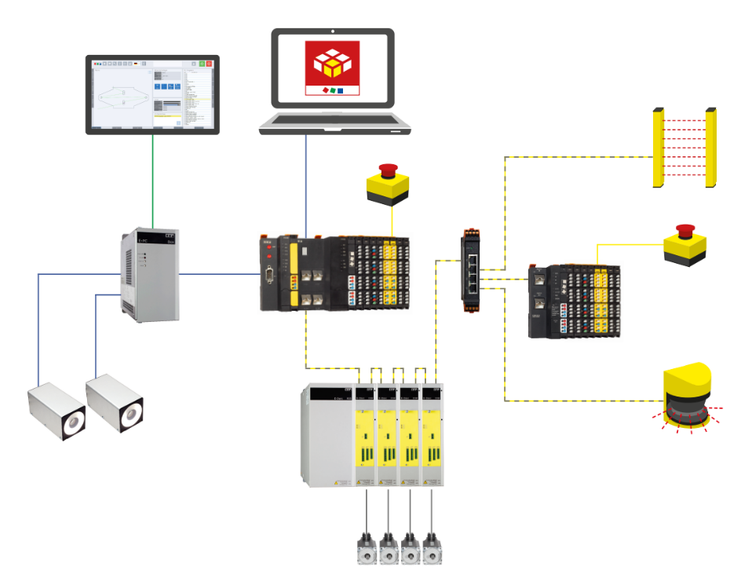
Caption 1: The E°SLC 89 safety controller from Eckelmann seamlessly combines automation and safety and also supports decentralized automation solutions for extensive machines via bus coupler. The system-wide communication is based on EtherCAT and FailSafe over EtherCAT (FSoE). The E°PLC designer with safety plugin, which is based on CODESYS V3, provides a single point of engineering for free programming of the PLC and safety application. This leads to a significant simplification and acceleration of the engineering process, since, for example, all signals and variables of the safe and non-safe PLCs can be accessed in a system-transparent manner for debugging. (Graphic: Eckelmann AG)

Wiesbaden, 09.11.2021: On the occasion of the SPS – Smart Production Solutions 2021, the automation manufacturer Eckelmann AG announces the market launch of its programmable safety controller E°SLC 89. This is certified according to IEC 61508 up to SIL3 or DIN EN ISO 13849-1 up to PLe. Visitors can obtain comprehensive information about the new product at the SPS in Hall 7, Booth 314.
Eckelmann has already successfully implemented the first applications with E°SLC 89 and the safe E°UBM I/O modules with pilot customers in mechanical engineering. The intuitive graphical programming environment makes it particularly easy to start developing safety applications. The E°PLC designer with safety plugin serves as a single point of engineering for both PLC automation and the safety application. The programming environment is based on the CODESYS V3 industry standard and is optimally adapted to the automation components from Eckelmann. Ready-to-use PLCopen-compliant safety modules are available in the integrated safety FBD editor for quick solution creation. An extensive library for typical safety tasks helps to quickly implement safety applications. Among other things, fail-safe function blocks are available for emergency stop, safety gate monitoring, two-hand control, operating mode selection, contactless safety guards (e.g. light grids) and much more.

Faster certification with SIL 3-certified safety technology
"Our goal in developing the E°SLC89 was to provide machine manufacturers with a safety controller that enables them to implement functional safety solutions quickly and cost-effectively," emphasizes board member Dr. Marco Münchhof and continues: "Intelligent and adaptable safety solutions are a real competitive advantage, especially during machine commissioning or setup, as they allow activities to be carried out safely and ergonomically in the actual hazardous area of the machine. In the implementation of such solutions, we at Eckelmann would like to provide our customers with our usual comprehensive support – from the development of holistic safety concepts and software engineering to the creation of tests for the safe and rapid commissioning of series machines. Training courses accompany this offer."

Safety without limits
The E°SLC 89 (dimensions: 52 mm x 120 mm x 76 mm) supports 1,024 bytes each for safe input and output data including exchange variables. This enables, for example, the connection of up to 170 FSoE slave modules, each with a maximum of 8 inputs and 8 outputs, or 128 FSoE slave modules and 256 bytes for variables that can be exchanged between the E°SLC 89 and the E°EXC 89.
A bus coupler is also available for decentralized safety solutions, via which I/O islands can be easily integrated. The modularly scalable E°UBM I/O system from Eckelmann thus also enables solutions for modular and/or extended machines or entire production lines.

Simple handling of safe and non-safe signals
The E°SLC 89 safety controller is connected directly to the E°EXC89 as an extension module; safe I/O modules can be mixed with normal I/Os and are connected directly to the E°EXC 89 or flexibly used remotely via bus couplers. EtherCAT as system bus and FailSafe over EtherCAT (FSoE) guarantees low cycle times and minimum jitter. Since safe and non-safe signals are transmitted together via the fieldbus, the cabling effort is also reduced immensely.

Functional safety as a competitive advantage
"It was important to us to take the complexity out of safety engineering," explains Dr. Marco Münchhof. "Software developers will therefore particularly appreciate the very intuitive graphical programming environment and the easy parallel access to data from the safe and non-safe controller. With ready-made function blocks, they can quickly create the safety logic for their application in the E°PLC designer. During tracing, safe and non-safe signals can be recorded together; the elimination of communication barriers is an enormous benefit for testing and debugging sophisticated machine software. The machine builder also benefits from the ideal coordination of the individual safety products from our portfolio, the safety controller, the safety I/O modules and the safe drive technology. The perfect interaction of all components ensures the highest level of safety with high machine availability at the same time. I am convinced: Functional safety and PLC automation can only grow together intelligently through this holistic approach. After all, safety and automation are two sides of the same coin. In the end, this enables more ergonomic and finely graduated safety concepts – both during the commissioning of complex machines and during operation and maintenance. For machine manufacturers, safety becomes thus considered not only a duty, but can serve to stand out from the competition with intelligent solutions. As a solution partner to the mechanical engineering industry, our customers can also rely on our comprehensive consulting and implementation expertise in the area of safety."
5.015 characters (including blanks)

Further information on safety technology from Eckelmann (controls, safe I/Os and drive controllers with integrated SIL 3 safety functions):
https://www.eckelmann.de/en/automation/safety-engineering/

Eckelmann @ SPS – Smart Production Solutions 2021
23.-25.11.2021, Nuremberg, Germany
Hall 7, Booth 314

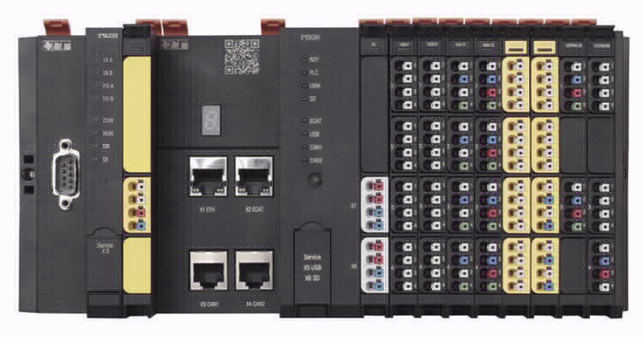
Caption 2: E°SLC 89 safety controller and E°EXC 89 controller for CNC, PLC and motion control applications as well as connected safe and non-safe I/O modules of the E°UBM family. (Photo: Eckelmann AG)

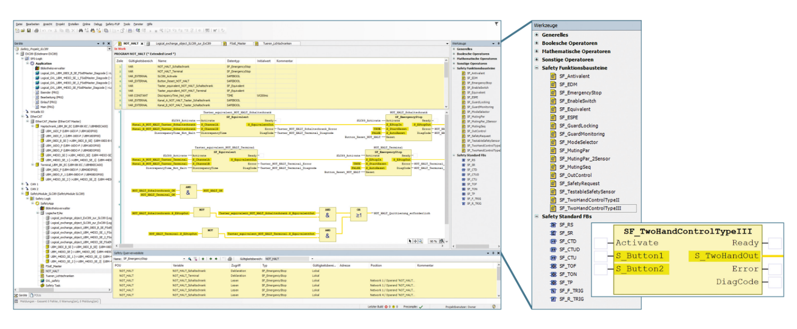
Caption 3: The E°PLC designer with safety plugin enables simple graphical programming of the safety application via drag & drop. Developers can access an extensive library of ready-made safety function blocks for this purpose. Parameterization is also carried out via the E°PLC designer. (Photo: Eckelmann AG)

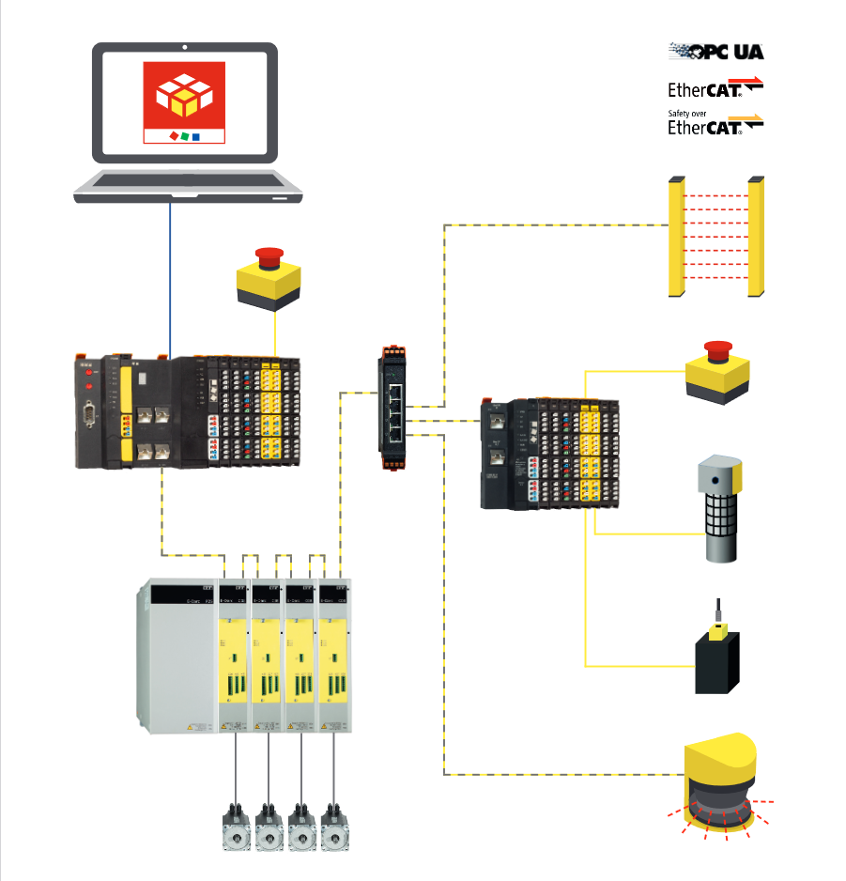

Caption 4: Safety without limits: The E°SLC 89 safety controller from Eckelmann seamlessly combines automation and safety and also supports decentralized automation solutions for extensive machines via bus coupler. The system-wide communication is based on EtherCAT and FailSafe over EtherCAT (FSoE).

About Eckelmann AG
Eckelmann AG, Wiesbaden, is a medium-sized automation partner for machine, device and plant construction. Its focus is on the development and series production of optimized control solutions for machines as well as programming and system integration for control and automation systems. Important target industries are: mechanical engineering, plant construction for metal and plastics processing, chemicals and pharmaceuticals, commercial refrigeration, food, basic and building materials, mills and the food industry, medical technology. Eckelmann AG was founded in 1977 by Dr.-Ing. Gerd Eckelmann. Around 525 employees of the Eckelmann Group generated an output of 73 million euros in the 2019 financial year.

www.eckelmann.de

Contact:  Eckelmann AG  Berliner Straße 161  65205 Wiesbaden  Germany  Tel.: +49 (0)611 7103-0  info@eckelmann.de  www.eckelmann.de | Media Relations:  Pressebüro Schwitzgebel  Im Krämereck 9  55276 Oppenheim  Germany  Tel.: +49 (0)172 6190178  info@presse-schwitzgebel.de  www.presse-schwitzgebel.de

