Change of name
Ferrocontrol becomes Eckelmann FCS
Herford / Wiesbaden, January 11th, 2021: With effect from December 28, 2020, Ferrocontrol Steuerungssysteme GmbH & Co. KG has been renamed Eckelmann FCS GmbH, associated with a simplification of the legal form from GmbH & Co. KG to GmbH. Ferrocontrol had been a subsidiary of Eckelmann AG since 2006. With the change of name, the company is now taking the last logical step of integration into the Eckelmann Group and making visible in the market what has grown together very successfully within almost 14 years.
As a unit, the two companies offer a complete portfolio of products and solutions for the automation and drive technology of machines and the smart factory. Managing Director Frank van Beek explains: “With this step we are expanding one of our proven strengths. Our customers have always valued our comprehensive, complete solutions from a single source. For customers and partners, we can now present our very broad competencies and technologies more clearly and effectively. With the Eckelmann umbrella brand, we are committed to our common skills and resources, which make us a highly innovative and efficient partner for international mechanical engineering."
The change of name will not result in any changes for employees, customers and suppliers. The unitary system will remain unchanged. All rights and obligations of the previous Ferrocontrol Steuerungssysteme GmbH & Co. KG are transferred to Eckelmann FCS GmbH.
1,392 characters (including blanks)
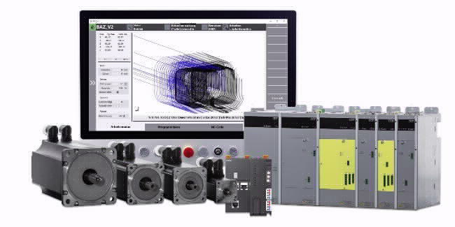
Caption 1: Eckelmann solution portfolio for machine automation (Photo: Eckelmann FCS)
Caption 2: Frank van Beek, Managing Director of Eckelmann FCS (Photo: Eckelmann FCS)

Contact:  Eckelmann FCS GmbH  Bodelschwinghstraße 20  32049 Herford  Tel.: +49 5221 966-0  info-fcs@eckelmann.de  www.eckelmann.de  Eckelmann AG  Berliner Straße 161  65205 Wiesbaden  Tel.: +49 (0)611 7103-0  info@eckelmann.de  www.eckelmann.de | Media Relations:  Pressebüro Schwitzgebel  Im Krämereck 9  55276 Oppenheim  f.schwitzgebel@presse-schwitzgebel.de  www.presse-schwitzgebel.de

