Press Release by Eckelmann AG
Temperature clearly in view
VDD 500 Virtus Data Display: The new temperature display from Eckelmann is extremely versatile. Even at a distance or in dark environments, the illuminated LED display is easy to read.
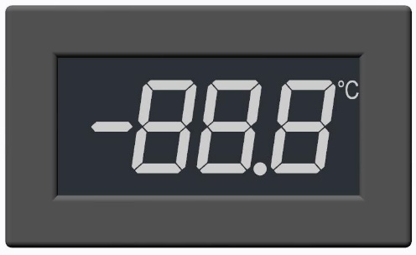
Caption: VDD 500 Virtus Data Display: Versatile LED temperature display from Eckelmann for freezer and refrigeration cabinets as well as cold rooms. (Photo: Eckelmann AG)
Wiesbaden (Germany), 18.11.2022: The new Virtus Data Display VDD 500 from Eckelmann displays temperature, defrost and alarm status in a visually appealing way. The LED temperature display with white digits is versatile. Among other things it is suitable for front installation in LT/NT refrigeration cabinet panels or for cold rooms. Thanks to the illuminated display, temperature and status can be easily read even in dark surroundings and at a distance, which eases the manual documentation of cold room temperatures, for example.
The Eckelmann UA 400 E, UA 401 E and UA 410 E refrigeration case controllers with 9-pin DIP switch are supported – from firmware version 3.20 or higher. Up to four VDD 500 temperature displays can be connected to each refrigeration controller – simply and cost-effectively via RS485 and at the display interface of the refrigeration controller. Shielded cables (LiYCY 2x2x0.25 mm² or J-Y(ST)Y 2x2x0.8 mm²) are recommended for Modbus cabling (RS485). A separate power supply is not necessary.
The signaling of alarms and defrost is self-explanatory. The three-digit display shows temperatures from -50°C to +100 °C of the allocated temperature sensor – from one of two temperature zones. Configuration and sensor allocation (temperature zones as well as supply and return air) are conveniently managed via the configuration software of the refrigeration controller or the system control center. With its dimensions of W 62 x H 29.5 x D 39 mm, the new compact LED temperature display also finds a perfect place where the well-proven BT 30 from Eckelmann has been used up to now. Refrigerated cabinet manufacturers and refrigeration specialists thus save on constructional adjustments when they switch to the new Virtus LINE generation from Eckelmann in the future. VDD 500 and BT 30 cannot be combined.
1.799 Characters (without headline and teaser)
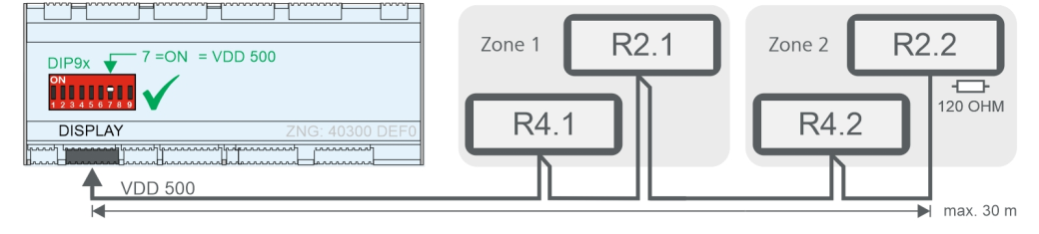
Caption 2: Connection example with maximum number of VDD 500: UA 400 E / UA 410 E refrigeration controller with two temperature zones and two temperature displays each for return air (R4.1/R4.2) and supply air (R2.1/R2.2). (Photo: Eckelmann AG)

About Eckelmann AG
Eckelmann AG, Wiesbaden, is a medium-sized automation partner for machinery, apparatus, and plant engineering. Its main focuses are the development and serial production of optimised control solutions for machinery and programming and system integration for control and automation systems. Important target industries are: Machine engineering, plant manufacturing for metal and plastics processing, chemistry and pharmaceuticals, commercial refrigeration, foodstuffs, basic and construction materials, mills and the food industry, medical technology. Eckelmann AG was founded in 1977 by Dr.-Ing. Gerd Eckelmann.
www.eckelmann.de

Contact:  Eckelmann AG  Berliner Straße 161  65205 Wiesbaden  Germany  Tel.: +49 (0)611 7103-0  info@eckelmann.de  www.eckelmann.de | Media Relations:  Pressebüro Schwitzgebel  Im Krämereck 9  55276 Oppenheim  Germany  Tel.: +49 (0)172 6190178  info@presse-schwitzgebel.de  www.presse-schwitzgebel.de

