Press Release from Eckelmann AG
Eckelmann founds subsidiary in France
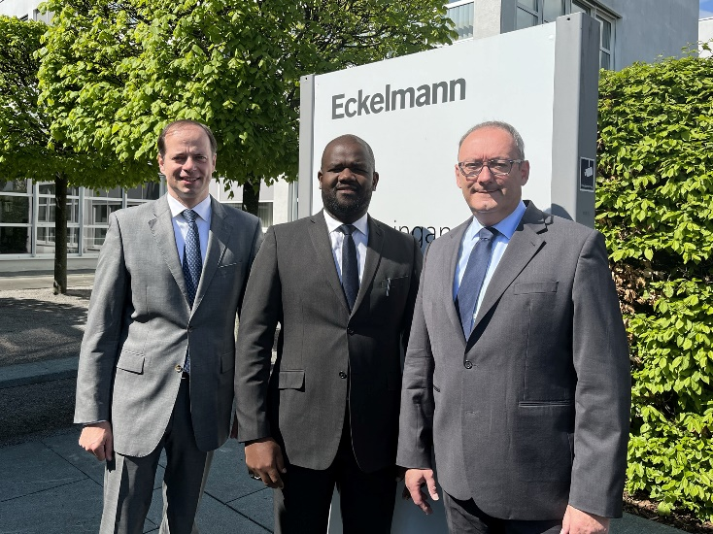
Picture 1: Congratulations on the new role: Baudelaire Meli Dountsop is the new General Manager of Eckelmann S.A.S. France. (From left to right: CEO Philipp Eckelmann, Baudelaire Meli Dountsop and Thomas Behr, Vice President Refrigeration & Building Automation). (Photo: Eckelmann AG)

Wiesbaden, 10/05/22: Eckelmann continues to expand its presence in France: the German automation provider founded Eckelmann S.A.S with head office in Lyon at the end of April 2022. Baudelaire Meli Dountsop has been appointed Directeur Général. Since 2019, he was already working as Sales Manager France, supporting existing and new customers in France and francophone European countries.
Eckelmann S.A.S. is now expanding its competence team in Lyon and, in addition to its focus on refrigeration and building automation, would like to increasingly act as a solution partner for industrial automation in mechanical and plant engineering in the future. For customers in France, Eckelmann's on-site presence means even more comprehensive technical and sales support without language barriers and simplified order processing. Satisfied customers already include numerous refrigeration specialists, food retailers and wholesalers, in addition to internationally operating machine builders.
Competent Franco-German economic cooperation
The Chamber of Commerce Abroad (AHK) is an important bridge between Germany and France: in the course of the start-up phase, Eckelmann received excellent support and advice from the Franco-German Chamber of Industry and Commerce (La Chambre Franco-Allemande de Commerce et d'Industrie). "We have found the cooperation with the AHK to be very fruitful," emphasises Thomas Behr, Vice President Refrigeration & Building Automation. "We benefit from the in-depth knowledge of the French market and practical information about legal issues. We also feel very well advised here when it comes to further developing business relations in France."
About the person: Baudelaire Meli Dountsop, Directeur Général at Eckelmann S.A.S.
Meli Dountsop has been involved with refrigeration and air conditioning technology since his school days in Cameroon. After graduating from a technical grammar school with this focus, he studied thermal engineering and energy in France. With a technical specialisation in refrigeration, he has obtained two master's degrees ‒ one in industrial engineering and one with focuses on quality, safety and the environment. Meli Dountsop gained professional experience at companies in the field of energy and air-conditioning technology, including a well-known French manufacturer of air-conditioning systems and chillers. Since 2019, Meli Dountsop has been instrumental in building Eckelmann's operations in France and identifying market opportunities for further growth. He speaks French, English and German.
3,353 characters (without headline)
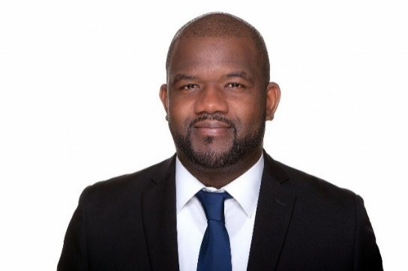
Picture 2: Baudelaire Meli Dountsop, Directeur Général at Eckelmann S.A.S. (Photo: Eckelmann AG)
About Eckelmann AG
Eckelmann AG, Wiesbaden, is a medium-sized automation partner for machinery, apparatus, and plant engineering. Its main focuses are the development and serial production of optimised control solutions for machinery and programming and system integration for control and automation systems. Important target industries are: Machine engineering, plant manufacturing for metal and plastics processing, chemicals and pharmaceuticals, commercial refrigeration, foodstuffs, basic and construction materials, mills and the food industry, medical technology. Eckelmann AG was founded in 1977 by Dr.-Ing. Gerd Eckelmann. Around 480 employees of the Eckelmann Group generated sales of 67,7 million euros in the 2021 financial year.
www.eckelmann.de
Contact:  Eckelmann AG  Berliner Straße 161  D-65205 Wiesbaden  Tel.: +49 (0) 611 7103-0  info@eckelmann.de  www.eckelmann.de | Media Relations:  Pressebüro Schwitzgebel  Im Krämereck 9  D-55276 Oppenheim  Tel.: +49 (0) 172 6190178  info@presse-schwitzgebel.de  www.presse-schwitzgebel.de

