Made-to-measure
OEM refrigeration controller for plug-in refrigerated cabinets

Wiesbaden (Germany), December 4, 2018: Eckelmann is expanding its portfolio with OEM solutions for plug-in refrigeration cabinets. With the VCC-PI-500 the company presented a prototype of the new Virtus Case Controller Plug-In series at this year's Chillventa. The modular electronic solution can be adapted exactly to the type of cabinet – from the hardware to the connections for sensors and actuators to customer-specific function and software adaptations.
The individual choice of construction and design means that the controllers can also be installed in refrigeration cabinets in a particularly space-optimized manner. Since only the functions required by the manufacturer are implemented, the controllers are extremely compact. The cabinet-specific connection technology also reduces wiring to a minimum. A clear connection assignment largely eliminates typical faults in switch box wiring. Even more convenient is the installation with cabinet-specific pre-assembled cable harnesses, which Eckelmann offers as an option.
With the new OEM solutions, manufacturers of refrigerated cabinets can accelerate the market launch of their appliances and reduce costs. Eckelmann develops and manufactures OEM controllers in its modern electronics production facility in Wiesbaden, Germany, from medium quantities – in high quality, thanks to automated test and inspection procedures.
Another advantage of the compact plug-in controllers is the possibility of easy connection to remote refrigeration systems. Central monitoring and management tasks can then be implemented via the E*LDS system control centre, for example, from alarming and temperature recording to time-controlled tasks for intelligent defrost management or lighting control. Plug-in solutions in discounters can thus be automated much more efficiently and safely.
1.788 Characters (without headline)

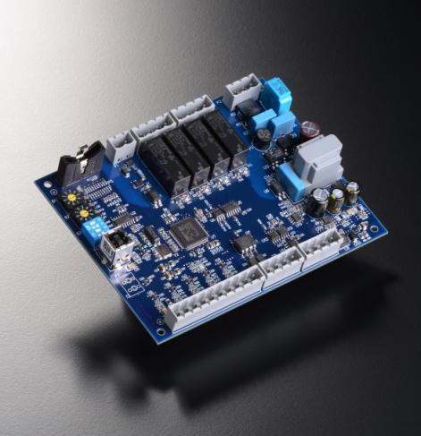

Caption: Compact and cost-effective: The new Virtus LINE OEM controllers from Eckelmann for plug-in refrigeration cabinets. (Photo: Eckelmann AG)

About Eckelmann AG
Eckelmann AG, Wiesbaden, is a medium-sized automation partner for machine and system engineering as well as cooling technology. The focus is on the development and series production of optimized control solutions for machines as well as programming and system integration for automation systems. Important target industries are: mechanical engineering, plant construction for metal and plastics processing, chemicals and pharmaceuticals, industrial and commercial refrigeration, raw materials and building materials, mills and food industry, medical technology. Eckelmann AG was founded 1977 by Dr.-Ing. Gerd Eckelmann.

www.eckelmann.de/en/

Contact:  Eckelmann AG  Berliner Straße 161  65205 Wiesbaden  Phone: +49 (0)611 7103-0  info@eckelmann.de  www.eckelmann.de | Media Relations:  Pressebüro Schwitzgebel  Felix Berthold  Berliner Straße 2  55283 Nierstein  Phone: +49 (0)6133 50954-1  Mobil: +49 (0)162 4367696  f.berthold@presse-schwitzgebel.de  www.presse-schwitzgebel.de

